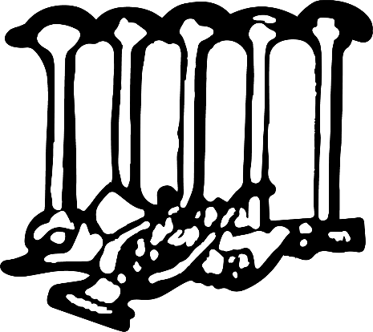
Shreveport-Bossier Opera Guild

In recognition of your support for the Shreveport Opera, you have been invited to join the Shreveport-Bossier Opera Guild. Founded in 1949 to promote the cultural aspects of opera in our community, the Guild has provided financial and volunteer support for seventy-five years. To accept this invitation, please pay online at https://square.link/u/38BLWlpT

OR mail check payable to the Shreveport-Bossier Opera Guild with this completed form to 4830 Line Avenue, Box #212, Shreveport, LA, 71106)

Name as you wish to be listed in membership directory:
________________________________________________________
Address:__________________________________________________
City:________________________________State:_____Zip:_________

Phone:___________________________________________________

Email:____________________________________________________

Membership Level:
- Individual ($40)
- New Life Member ($1500)
- Couple ($60)
- Patron ($100 towards Lifetime Membership balance)
- Donation: _________
Thank you!

